Computer Organization and Assembly Language
Lecture 1
What is Computer Organization
Computer Organization is the study of how the different parts of a computer are connected and how they work together.
It explains the inside structure of a computer and how it works, including the CPU (brain of the computer), memory (for storing data and instructions), input/output devices (like keyboard, mouse, screen, printer), and the way all these parts are linked with each other.
Continue…
Computer Organization means learning how a computer works “behind the scenes.”
It shows how the different hardware parts are arranged and how they work together to do tasks.
Key Points:
- Functional units: The main parts of a computer (CPU, memory, input/output devices).
- Interconnections: The way these parts are linked so they can share information.
- Control signals: Special signals that guide and control the actions of each part.
- Data flow: The movement of data from one part of the computer to another.

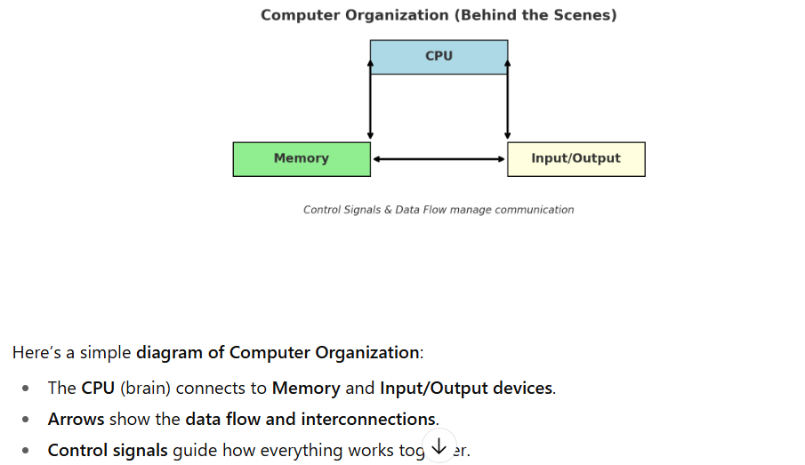
Components of Computer
1. CPU (Central Processing Unit)
- The brain of the computer.
- It does all the thinking, calculations, and decision-making.
- Example: Solving math problems, running apps, controlling data flow.
2. Memory
- The storage place inside the computer.
- Keeps data and instructions temporarily or permanently.
- Example: RAM (temporary memory) and Hard Drive/SSD (long-term storage).
3. Input Devices
- Devices that send information into the computer.
- Example: Keyboard, mouse, microphone, scanner.
4. Output Devices
- Devices that show results from the computer.
- Example: Monitor (screen), printer, speakers, projector.
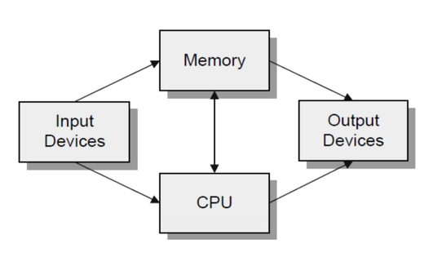
Central Processing Unit (CPU)
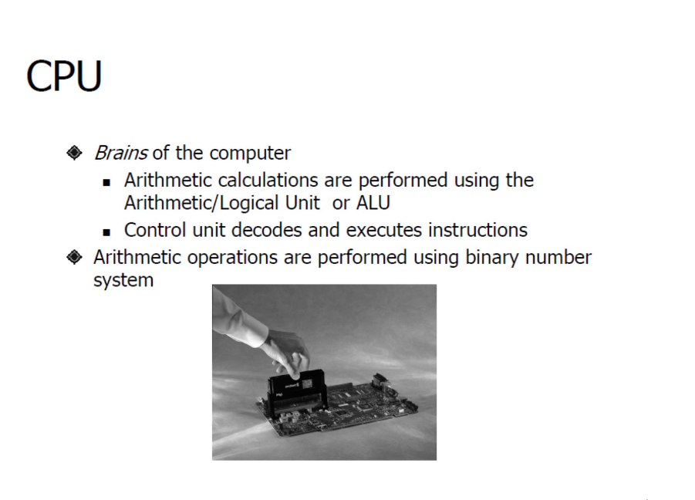
Control Unit
The control unit is the part of the CPU that directs all the operations. It uses a three-step process called the fetch/execute cycle to run a program's instructions.
- Fetch the instruction: The CPU gets the next instruction from memory. A special register, the program counter (PC), keeps track of which instruction to get next by holding its memory address.
- Increment the PC: The CPU updates the program counter to point to the next instruction in the sequence.
- Execute the fetched instruction: The CPU performs the action specified by the instruction.
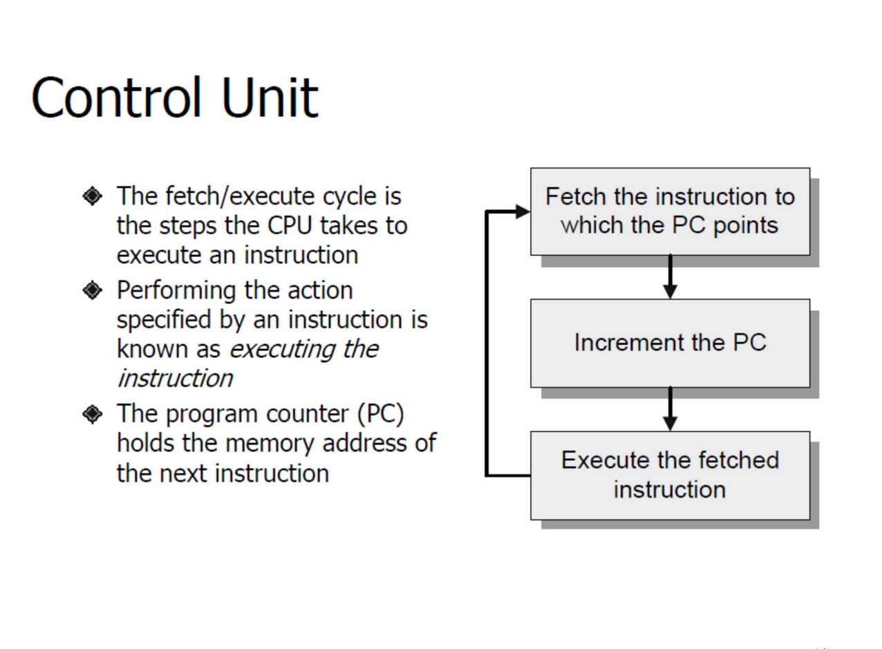
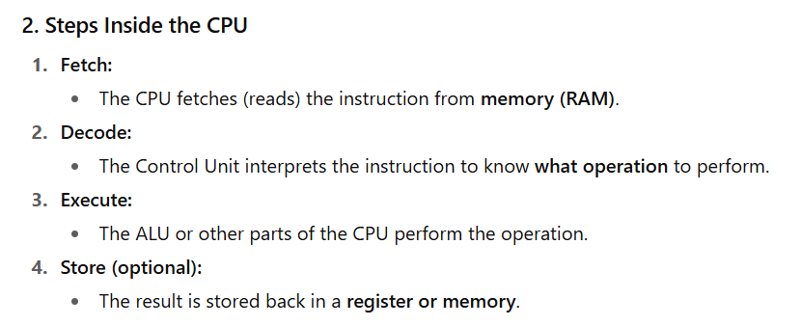

Program Counter
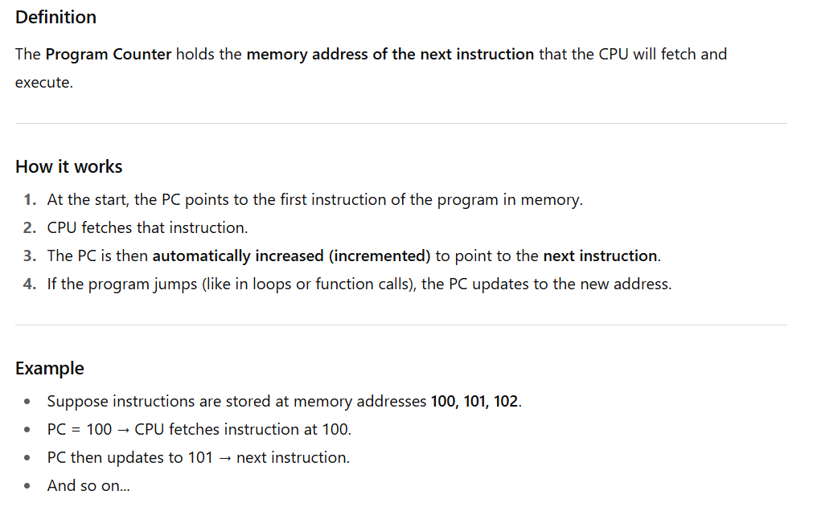
Input and output Devices
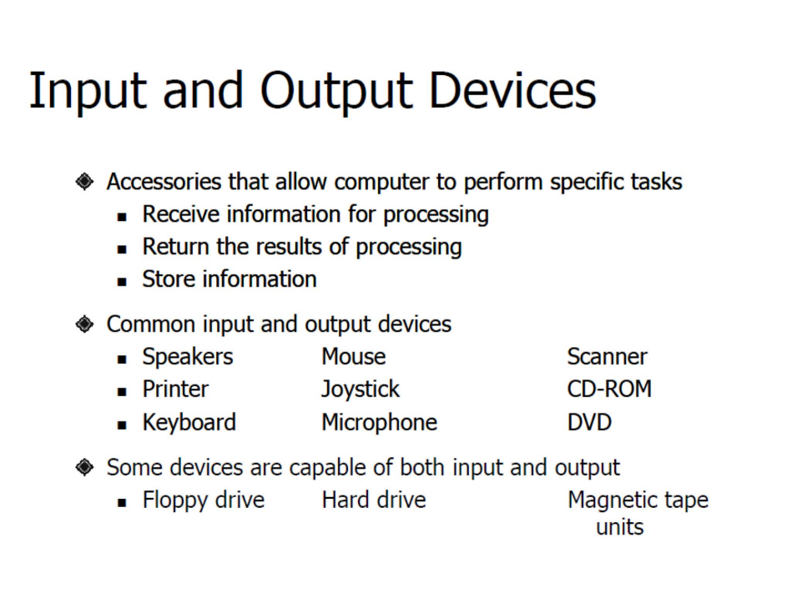

Monitor
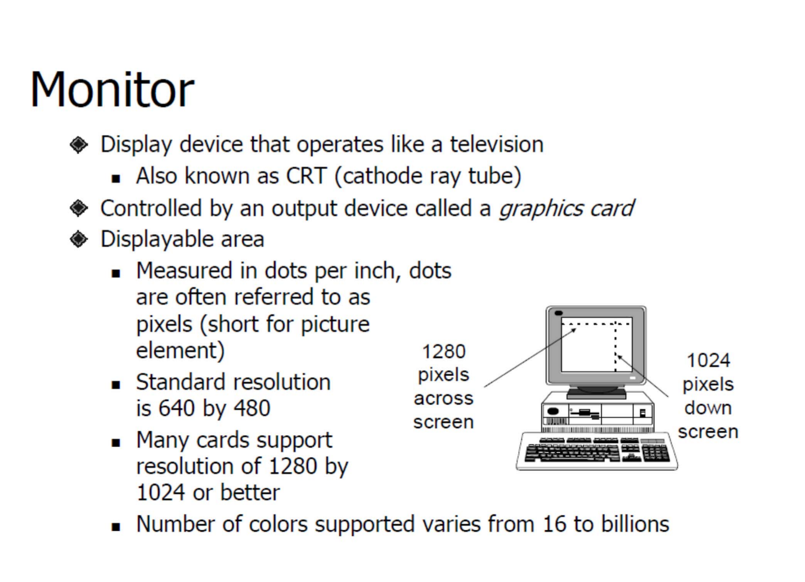
Software and its types
Software is a set of instructions, programs, or data that tells a computer how to perform specific tasks. Unlike hardware, which is the physical part of a computer (like the CPU, monitor, or keyboard), software is intangible—it exists as code and programs.
There are two main types of software:
- System Software: Helps run the computer and its hardware. Example: Operating Systems like Windows, macOS, or Linux.
- Application Software: Helps users perform specific tasks. Example: Microsoft Word, web browsers, or games.
Operating System
An Operating System (OS) is a special type of system software that acts as a bridge between the computer hardware and the user. It manages the computer’s resources and makes it easier for users and other software to interact with the hardware.
Services
- Process Management
- Memory Management
- File System Management
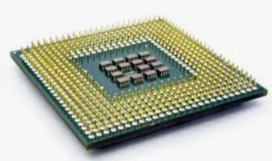
Microprocessor
A microprocessor is a small electronic chip that acts as the brain of a computer or device. It performs calculations, executes instructions, and controls other parts of the system.
- It is the CPU on a single chip.
- Found in computers, laptops, and even some smart devices.
Example: Intel i3, i5, i7, AMD Ryzen, etc.

Components
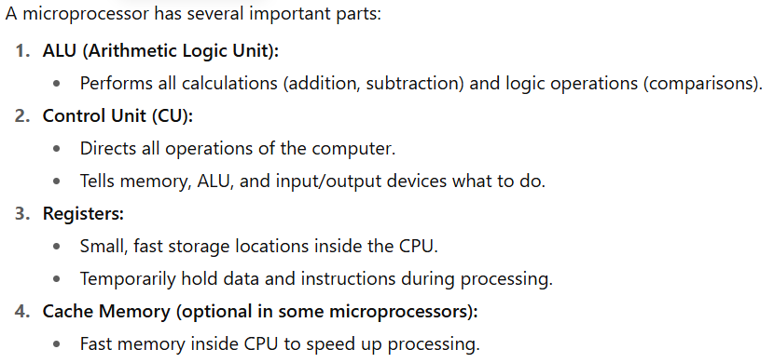
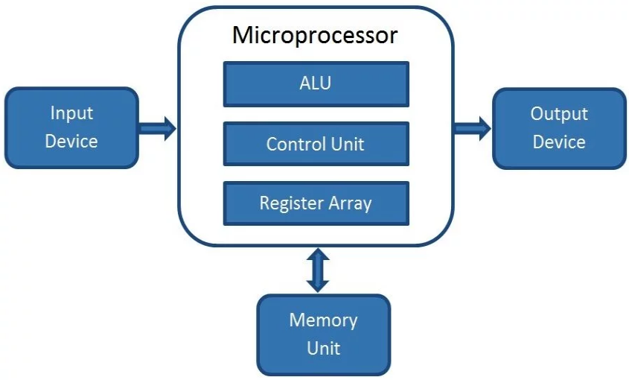
Microcontroller
A microcontroller is like a microprocessor + extra components on a single chip.
- It has a CPU, memory (RAM & ROM), and input/output ports all in one chip.
- Used in embedded systems for controlling devices.
Example: Arduino, PIC, and STM32.
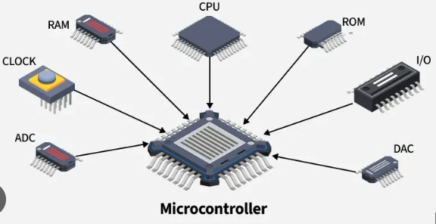
Difference between twos
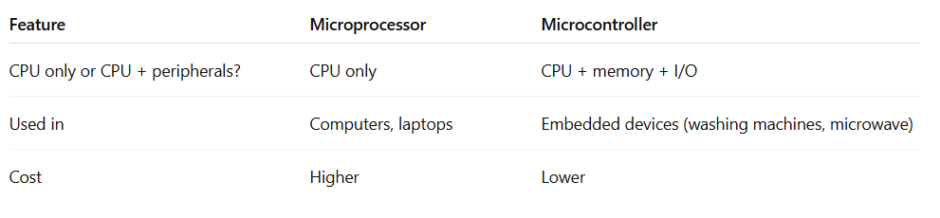
Embedded System
An embedded system is a special-purpose computer built to do a specific task.
- It usually uses a microcontroller.
- It is not general-purpose like a PC.
Examples:
- Washing machines
- Microwave ovens
- Digital cameras
- Smart watches
Direct Memory Access
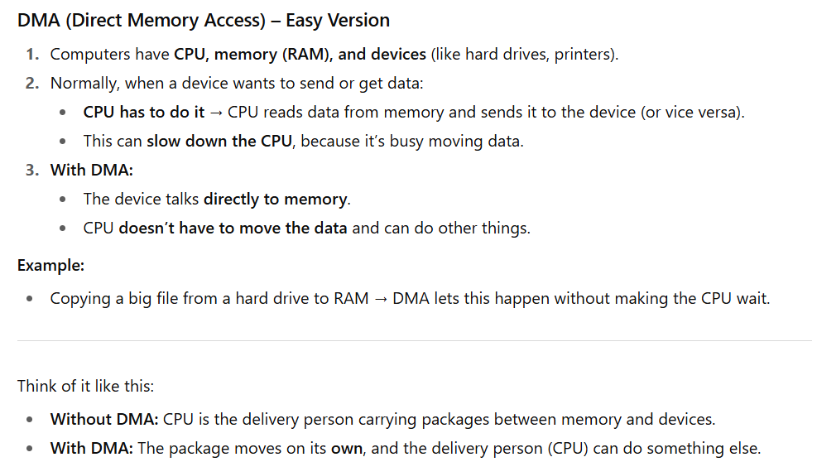
Drivers
A driver is a special software program that allows the operating system to communicate with hardware devices.
- Without drivers, the OS cannot understand or control hardware like printers, keyboards, or graphics cards.
- Think of it as a translator between the OS and the hardware.
Example:
- Printer driver lets your computer send documents to the printer.
- Graphics driver lets your OS use the GPU for display and gaming.

Word Length
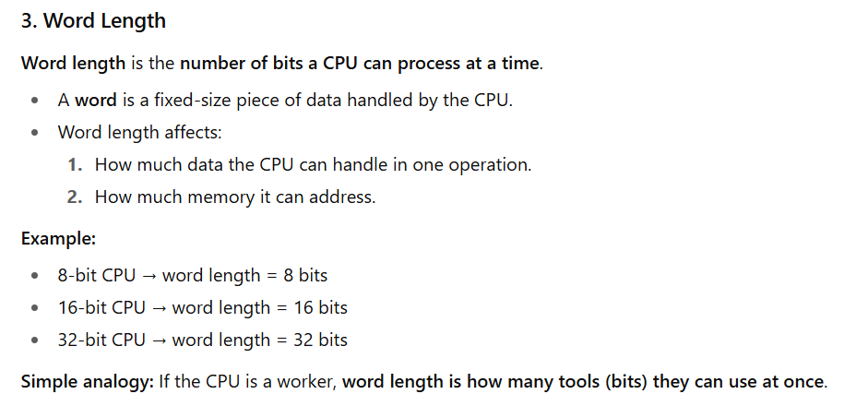
Buses
1. Data Bus
- Purpose: Carries data between the CPU, memory, and devices.
- Two-way traffic: Data can move to or from the CPU.
- Example: Sending a number from memory to the CPU for calculation.
2. Address Bus
- Purpose: Carries the address/location of memory or I/O devices that the CPU wants to read from or write to.
- One-way traffic: Usually from CPU to memory/device.
- Example: Telling memory, “I want the data stored at location 100.”
3. Control Bus
- Purpose: Sends control signals to manage and coordinate all actions of the CPU, memory, and devices.
- Examples of signals:
  - Read (CPU wants to read from memory)
  - Write (CPU wants to write to memory)
  - Clock signals and interrupts
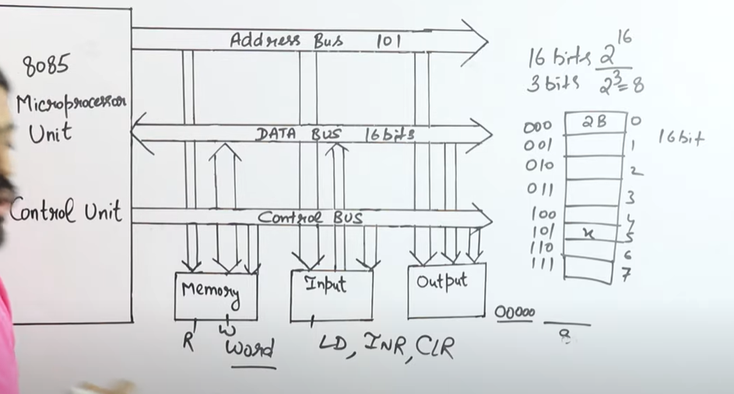
MAR, MDR and Instruction Register
1. MAR (Memory Address Register)
- Meaning: It holds the address of the memory location that the CPU wants to access (read or write).
- Role: Think of MAR as the "pointer" telling the CPU where in memory to look.
- Size: Its size depends on the size of the address bus (e.g., if the CPU has 16-bit addresses, MAR is 16 bits).
2. MDR (Memory Data Register)
- Meaning: It holds the data that is either:
  - Read from memory (to be used by CPU), or
  - Written into memory (sent from CPU).
- Role: Think of MDR as a "buffer" that temporarily stores data being transferred.
- Size: Its size matches the word size of the computer (e.g., 32-bit CPU → MDR is 32 bits).
3. Register (IR)
- The Instruction Register (IR) is a special-purpose register inside the CPU.
- It holds the current instruction that the CPU has just fetched from memory and is about to decode and execute.
- Once the instruction is in the IR, the Control Unit (CU) reads it, breaks it into the opcode (what to do) and the operands (data or addresses), and then generates control signals to carry out the task.
- The IR is updated in every fetch cycle, meaning with each new instruction, it replaces the old one
Instruction Cycle (Fetch–Decode–Execute)
1. Fetch
The fetch stage is the process of getting the next instruction from memory. The Program Counter (PC) holds the address of the instruction that needs to be executed. This address is copied into the Memory Address Register (MAR), and the Control Unit sends a Read signal to memory. The instruction stored at that memory location is then moved into the Memory Data Register (MDR) and transferred into the Instruction Register (IR) for further processing. Meanwhile, the PC is incremented so it points to the following instruction, ensuring the CPU is ready for the next cycle.

2. Decode
In the decode stage, the CPU interprets the instruction that has been fetched. The Decoder, which is part of the Control Unit, examines the bits stored in the Instruction Register (IR). It separates the opcode, which specifies the operation to be carried out (such as ADD, MOVE, or LOAD), from the operands, which indicate the data or memory addresses involved. Based on this information, the Control Unit generates the appropriate control signals needed for the next stage of execution.
3. Execute
The execute stage is where the CPU performs the actual operation defined by the instruction. If the instruction is a memory read (LOAD), the operand’s address is placed in the MAR, the data is fetched into the MDR, and then moved into a CPU register. If it is a memory write (STORE), the address is placed in the MAR, the data is loaded into the MDR, and then written to memory. For arithmetic or logic instructions (such as ADD or SUB), the operands are sent to the ALU, the operation is performed, and the result is stored in a register or in memory. For I/O operations, the CPU communicates with input or output devices either through memory-mapped I/O using MAR and MDR, or through special I/O instructions in port-mapped systems.
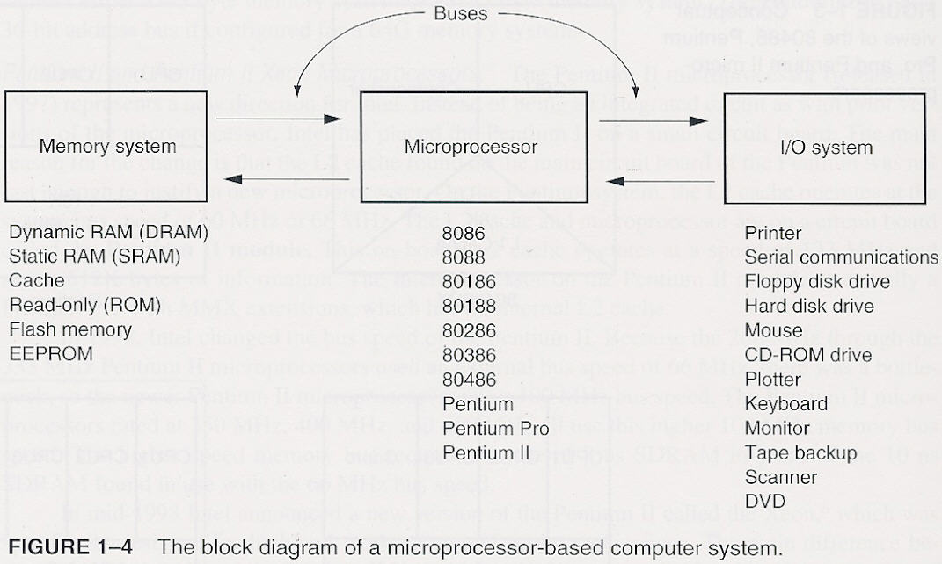
Interpretation of figure
The provided diagram shows the architecture of a microprocessor-based computer system. The microprocessor acts as the central processing unit, or "brain," of the system. It is connected to the memory system, which stores data and instructions, and the I/O (Input/Output) system, which handles communication with external devices like keyboards and monitors. These components are interconnected by buses that allow for the flow of information.
The flow of instructions is from memory to the microprocessor, not from I/O devices. The microprocessor fetches instructions from memory, processes them, and then uses the I/O system to interact with the user and external devices as needed.

